CAMPING
One overnight campout on the beach premisis is allowed with permission from any Board member. More than one night of camping must be approved by the Board of Directors. If campers require a fire in a location other than the fireplace, it must be approved by Board members. If an alternate site is used, great care must be taken to remove all traces of ashes and embers prior to departure.

PREPARATION & CLEAN-UP___________________
Trash must be removed from the beach premises after every social gathering. Excess sand shall be swept from decktops and tabletops. The Beach House must be left in good order. The host of every event is responsible for basic cleanliness of the compostible outhouse––both before and after their event. This includes:
*Wipe toilet seat & bench area. Sweep floor.
*Insure that plastic bin in outhouse is filled with sawdust. Extra sawdust stored in black bag under beach house.
*Empty contents of the bag under toilet seat into composting bin at the end of Roger’s Island, put new trash bag in bucket.

BOAT STORAGE______________________________
The area east of the dock retaining wall is designated as a boat storage area.
PARKING_____________________________________
Vehicles shall park in the designated parking area. Parking behind the canopy is for loading and unloading only. The roadway leading to the beach must be clear.

SECURITY GATE______________________________
The cable snap gate at the beginning of the beach road will now be kept up year round, in order to deter use/exploring of the beach premesis by unauthorized persons. Always snap the gate up if you are the last one out after use or an event.

DIVING_______________________________________
No diving (defined as a headfirst plunge) is allowed at any time from anywhere on the the dock or any rocks.

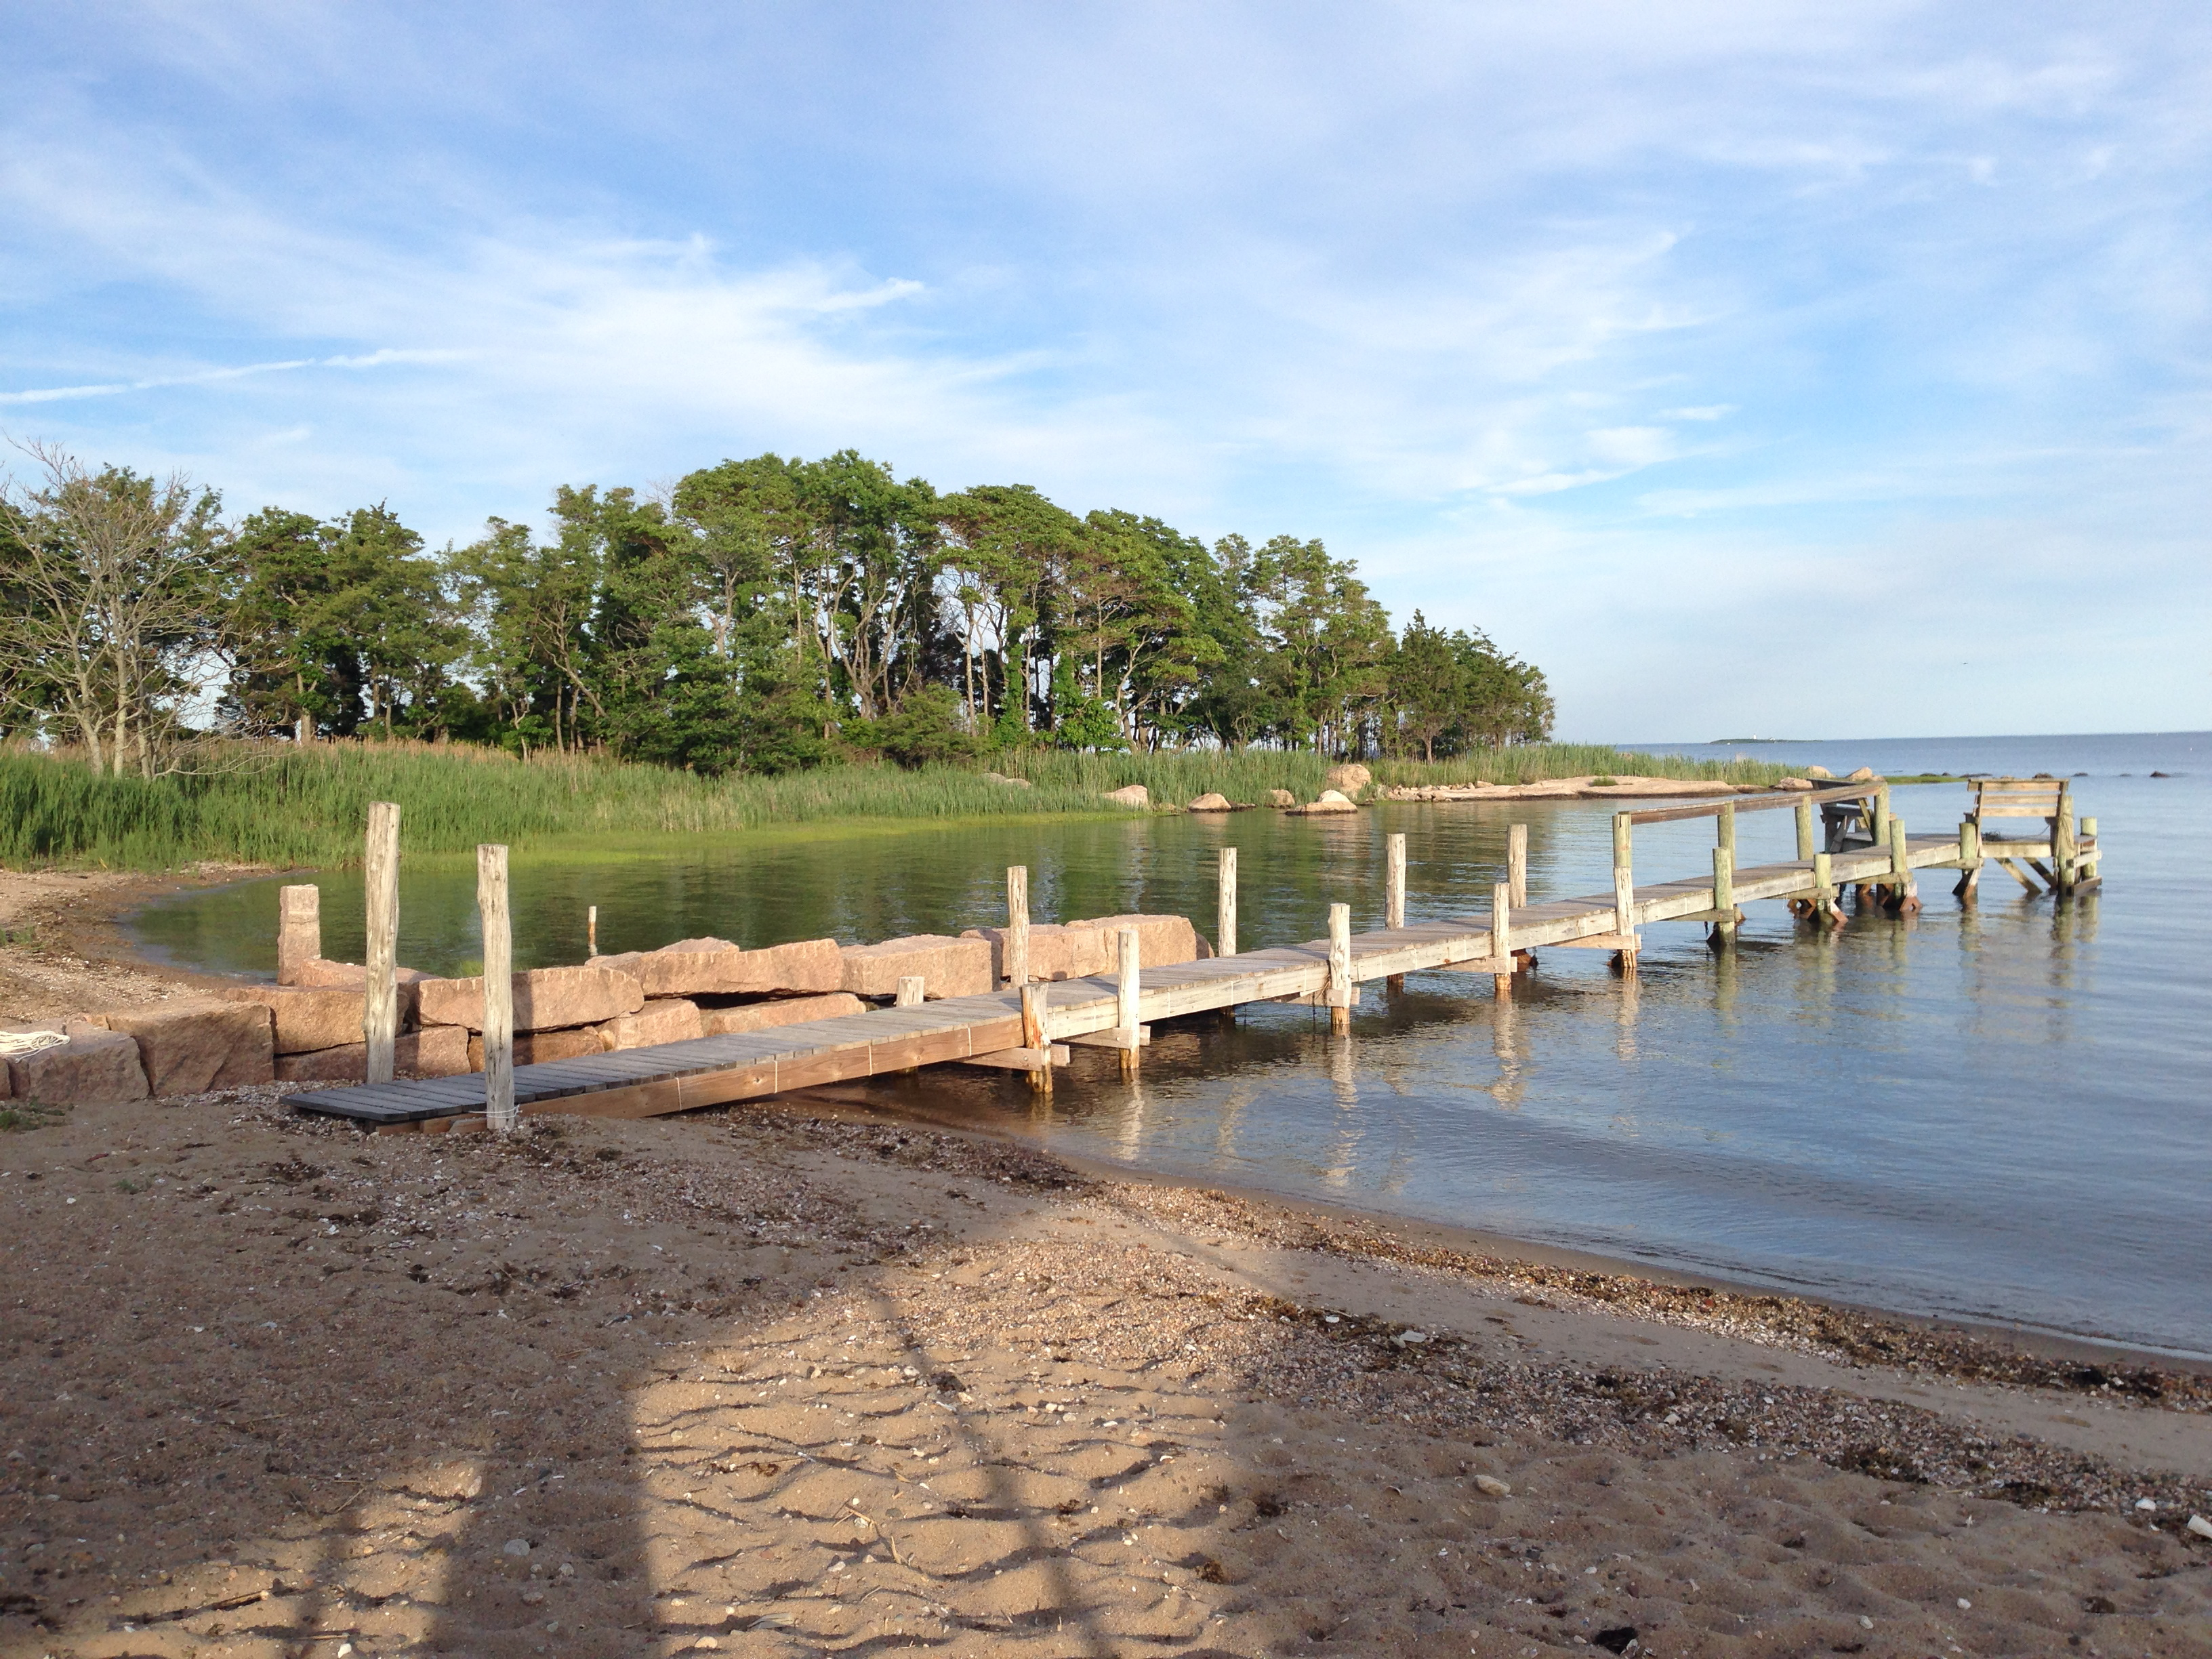

BENTON BEACH
Sachem’s Head
Guilford, CT

–Rules & Regulations–
June 2019 revision

There is only one Benton Beach. Eliot H. Benton’s children, grandchildren, and great grandchildren know that and appreciate that.
Sometimes they even realize how easy it is to take this one perfect spot in Sachem’s Head for granted. Perfect because it is beautifully private––both in physical setting and in exclusive family ownership.
Benton Beach Corporation pools the resources of the lineal descendents of the late Eliot H. Benton to maintain a large tract of the former “Sachem’s Farm,” including Benton Beach. Fifty-one (51) shareholders in three generations and living in sixteen(16) states of the U.S. are the legal owners-in-common. From all points of the compass, their families variously return to enjoy an exquisite inheritance made possible through Florence and Eliot Benton’s vision.
It is unusual that while many corporations seek to develop, this corporation seeks to preserve. The family corporation’s over-riding purpose is stated as objective in its Certificate of Incorporation, which is “to preserve to the greatest extent possible the natural resources of said lands...”
The Board of Directors of Benton Beach, Inc. issues these rules and regulations, believing that a system of order will increase our fun and enjoyment

GUESTS_______________________________________
Guests shall use the beach area only when accompanied by their host/s. Hosts are lineal descendents of Eliot H. Benton and/or their current spouses or have deeded beach privileges, or are shareholders in BBC.
DOGS_________________________________________
Dogs are allowed on beach premises only from September 15th-May 15th. However, even during this period, dogs are not allowed at scheduled events or overnight. Owners MUST clean up after their dog
SPECIAL EVENTS______________________________
Special events, such as picnics and parties, shall be scheduled in advance and will be approved by members of the Board. The Board is the clearing house so that conflicts can be avoided. A scheduled event is a non-exclusive use of the beach; i.e. other regular beach use may occur at the same time. All scheduled events will be posted on the BBC Facebook page and also on the BBC website Calendar of Events at www.bentonbeach.com. The site is password protected, user name: bbcfamily, password: sticktogether. The host of impromptu events of twenty (20) or more persons should speak to a Board member to give proper courtesy notice.
A guest book containing an indemnity/waiver release clause is kept on top of the corner cabinet in the beach house. All family members hosting a scheduled event at the beach must have non-family attendees sign this book.

Any direction signs posted on Vineyard Point Road should not direct attention to the name of the beach; rather, to the name of the event.

ALCOHOLIC BEVERAGES__________________________
State laws pertaining to alcoholic beverages shall be recognized on the beach premises. Connecticut General Statute 30-86 establishes age 21 as the legal drinking age. Absolutely NO underage drinking is allowed. All hosts are responsible for the conduct and safety of their guests.

FIREPLACE & FIREWORKS______________________
Fires in the fireplace must die down to embers before leaving the premises. DO NOT use water in the fireplace to extinguish the fire as this could crack the cement pad. Sand should not be used to put out the fire. Old cold embers present in the fireplace should be shoveled into the metal bucket in the firepit and deposited in the ash receptacle spot behind the boat storage area. Large fires and bonfires are prohibited due to the deterioration of the granite. The cooking grate is to remain in place. The discharge of fireworks are prohibited under applicable local ordinance and State law.

