CAMPING_____________________________________
One overnight campout on the beach premises is allowed with permission from any Board member. More than one night of camping must be approved by the Board of Directors. If campers require a fire in a location other than the fireplace, it must be approved by Board members. If an alternate site is used, great care must be taken to remove all traces of ashes and embers prior to departure.
PREPARATION & CLEAN-UP___________________
Trash must be removed from the beach premises after every social gathering. Excess sand shall be swept from decktops and tabletops. The Beach House must be left in good order. The host of every event is responsible for basic cleanliness of the compostible outhouse––both before and after their event. This includes:
*Wiping toilet seat & bench area. Sweeping floor.
*Insuring that plastic trash can in outhouse is
filled with sawdust. Raking back the pile in the
collection bin, if needed.
BOAT STORAGE______________________________
The area east of the dock retaining wall is designated as a boat storage area.

PARKING_____________________________________
Vehicles shall park in the designated parking area. Parking behind the canopy is for loading and unloading only. The roadway leading to the beach must be clear.

SECURITY GATE______________________________
The security gate/cable on the Beach Road should be closed during the period, November 1–May 1.

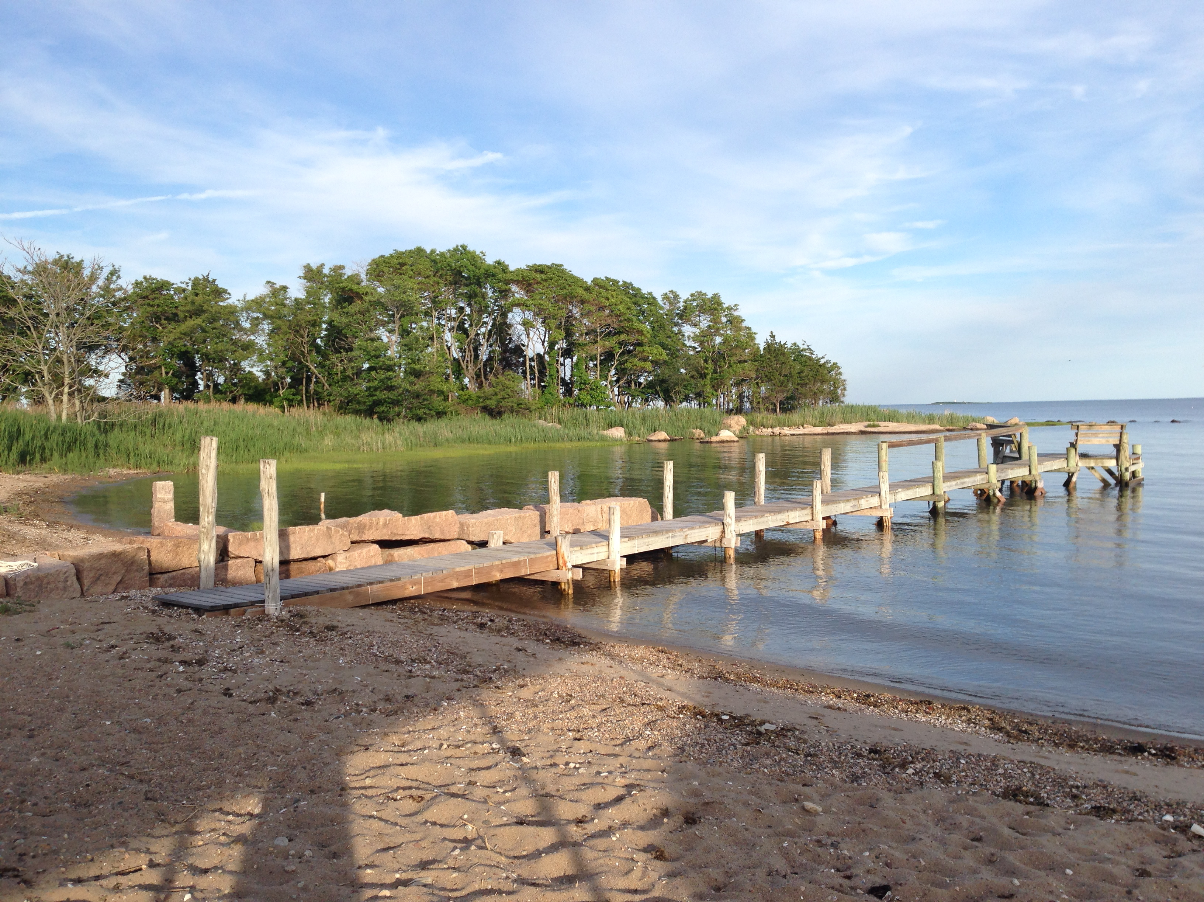

BENTON BEACH
Sachem’s Head
Guilford, CT

–Rules & Regulations–
March 2016 revision

There is only one Benton Beach. Eliot H. Benton’s children, grandchildren, and great grandchildren know that and appreciate that.

Sometimes they even realize how easy it is to take this one perfect spot in Sachem’s Head for granted. Perfect because it is beautifully private––both in physical setting and in exclusive family ownership.

Benton Beach Corporation pools the resources of the lineal descendants of the late Eliot H. Benton to maintain a large tract of the former “Sachem’s Farm,” including Benton Beach. Forty-one (41) shareholders in four generations and living in twelve(12) states of the U.S. are the legal owners-in-common. From all points of the compass, their families variously return to enjoy an exquisite inheritance made possible through Florence and Eliot Benton’s vision.

It is unusual that while many corporations seek to develop, this corporation seeks to preserve. The family corporation’s over-riding purpose is stated as objective in its Certificate of Incorporation, which is “to preserve to the greatest extent possible the natural resources of said lands...”

The Board of Directors of Benton Beach, Inc. issues these rules and regulations, believing that a system of order will increase our fun and enjoyment.

GUESTS_______________________________________
Guests shall use the beach area only when accompanied by their host/s. Hosts are lineal descendents of Eliot H. Benton and/or their current spouses or have deeded beach privileges, or are shareholders in BBC.

DOGS_________________________________________
Dogs are allowed on beach premises only from October 1st-April 1st. Owners must clean up after their dog.

SPECIAL EVENTS______________________________
Special events, such as picnics and parties, shall be scheduled in advance by contacting the BBC Secretary and will be approved by members of the Board. The Board is the clearing house so that conflicts can be avoided. A scheduled event is a non-exclusive use of the beach; i.e. other regular beach use may occur at the same time. All scheduled events will be posted on the BBC website Calendar of Events at www.bentonbeach.com. The site is password protected- the user name is bbcfamily and password is sticktogether. The host of impromptu events of twenty (20) or more persons should speak to a Board member to give proper courtesy notice.
A guest book containing an indemnity/waiver release clause is kept on top of the corner cabinet in the beach house. All family members hosting a scheduled event at the beach must have non-family attendees sign this book.
Any direction signs posted on Vineyard Point Road should not direct attention to the name of the beach; rather, to the name of the event.

ALCOHOLIC BEVERAGES_____________________
State laws pertaining to alcoholic beverages shall be recognized on the beach premises. Connecticut General Statute 30-86 establishes age 21 as the legal drinking age. Hosts are responsible for the conduct and safety of their guests.

FIREPLACE & FIREWORKS______________________
Fires in the fireplace must be died down to embers before leaving the premises. DO NOT use water in the fireplace to extinguish the fire as this could crack the cement pad. Sand also should not be used to put out the fire. If old, cold embers are present in the fireplace, they should be shoveled into the metal bucket in the firepit and deposited in the ash receptacle spot behind the boat storage area. Large fires and bonfires are prohibited due to the deterioration of the granite. The cooking grate is to remain in place. The discharge of fireworks are prohibited under applicable local ordinance and State law.

