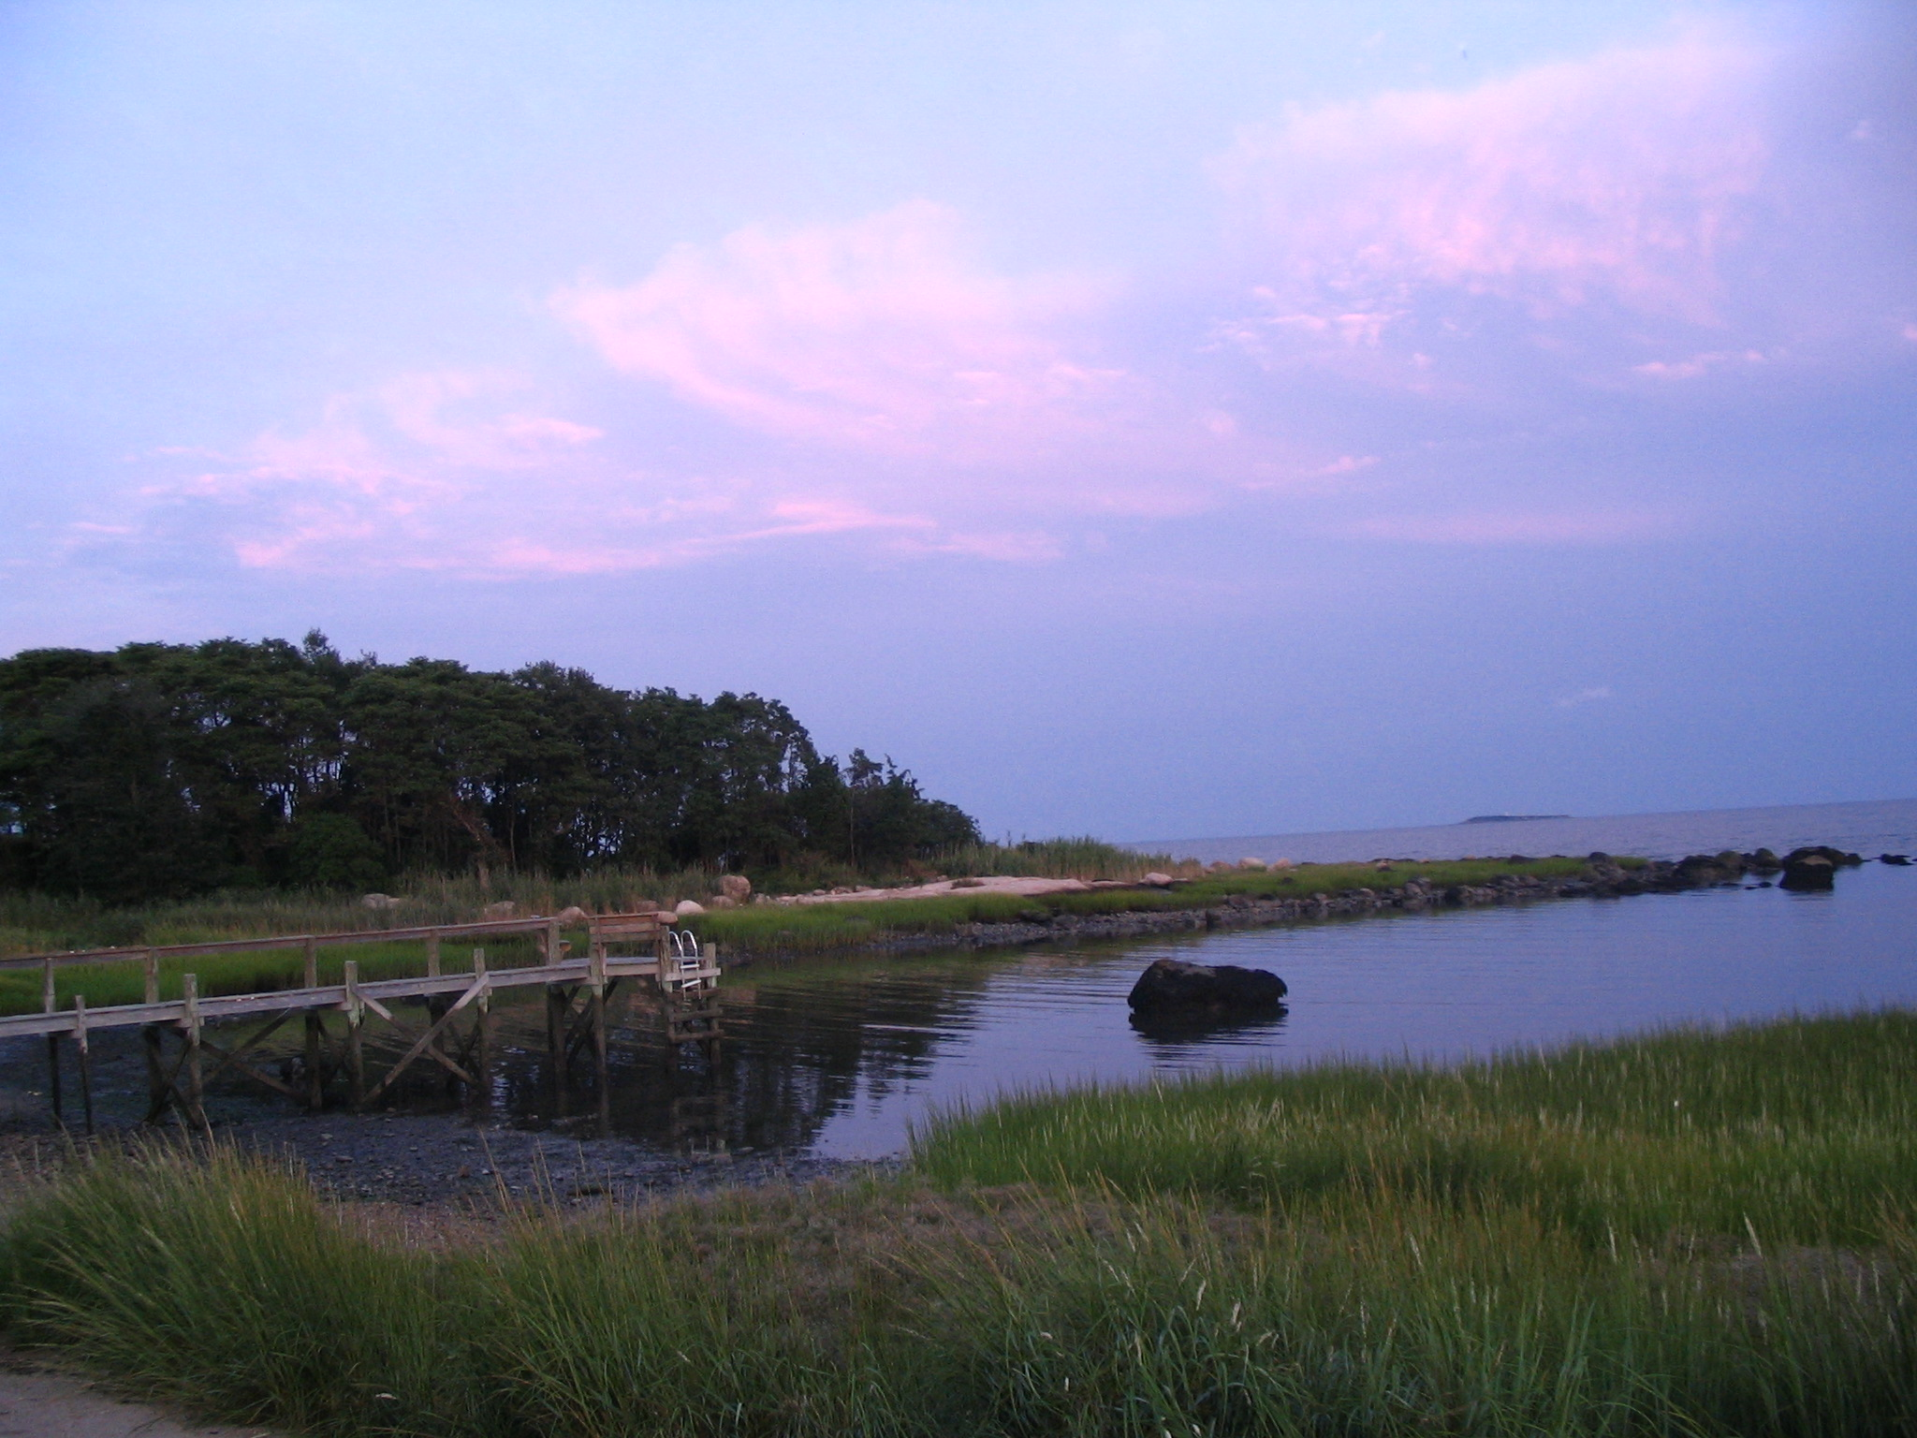 BBC Spring Workday
Saturday, May 19th
8:30 a.m……..
(Downpour date Sunday, May 20^{th)}

Come one and all to our annual workday! We will continue our work on making the beach better than ever. We are still putting the beach back together after the devastation caused by Hurricane Irene last August. David has been working all winter on the dock and it is looking wonderful! Our efforts on workday will be to continue to clean up and repair as much as we can. We will be collecting/raking debris on Roger’s Island and in the parking lot, shoveling sand from the back of the fireplace, setting the stringers for the canopy decking and re-setting and repairing the deck pieces. A few Trex dock pieces washed up during the hurricane. We are hoping to have enough Trex to lay it on top of our existing deck pieces, making a smooth and splinter-free deck! We will also clean out the beach house, put the canopy up and rake seaweed.
Bring metal rakes, pitchforks, gloves, shovels, drills, chain saws, a
wheelbarrow!
Breakfast treats and lunch will be provided.
Also, this coming Saturday, April 21st, is a special workday. David Ott’s boy scout troop will be at the beach from 9am on to focus on cleaning the long lot and meadow. There is so much debris and trash left from the hurricane that the cattle cannot come in until it is removed. It is a huge job, one that cannot be fully appreciated until you are actually in the meadow and see it! The help of any family members would be so welcomed and appreciated! There is a need for pitchforks, hay rakes, wire rakes, clawhammers, crowbars and trucks!!

